Intellectual property law LAWS20014

**Nature of IP** **2**

Tangible vs Intangible 2

Intellectual property rights (IPR) 3

**Copyright requirements** **4**

**Different types of work that can be copyrighted** **4**

Literary work 4

Dramatic work 4

Musical work 5

Artistic work 5

Sound recording 5

Cinematographic film 5

Sound/ TV broadcast 5

Published Edition (not a work?) 5

**Requirements to classify as a work** **5**

**Exclusive rights for copyright** **6**

**Fair dealing purposes** **7**

**Authorship** **8**

Multiple authors 8

Makers 9

**Exceptions to ownership of copyright** **9**

**Assignments and Licences of Copyright** **9**

**Divisibility of copyright** **10**

**Implied vs expressed license** **10**

**Duration of copyright** **10**

Where the author is unknown: 11

Duration of other subject matter: 11

**Protection of secrets** **11**

Requirement to restain a breach of confidence 12

Limitation on Availability of a Remedy-Unreasonable Restraint of Trade 12

**Patent** **13**

Patent application process 13

**Patentable subject matter** **14**

**Patent specification** **16**

Requirement for utility 16

Requirement of novelty 16

**Patent infringement** **18**

Multi-Step Approach to Construction 18

Defenses to Infringement 19

**Trademark** **19**

Prohibitions on trademarks 21

Obtaining trade mark registration 22

Infringement of trademark 23

Determining substantial similarity 24

Determining deceptive similarity 25

Goods or service of the same description/ closely related 27

Well known marks 29

Use as a trade mark 29

**Protection against Misleading or Deceptive Conduct** **29**

**Exam** **32**

# Nature of IP

## Tangible vs Intangible

| **Tangible** | **Intangible** |
| --- | --- |
| Eg: Egyptian manuscript | Eg: PDF |
| Rivalrous: Only one person can use at a time | Non-rivalrous: Many people can use at the same time |
| Exhaustible: Wears out over time | Non-exhaustible: Does not wear out over time |
| Excludable: Can be possessed to the exclusion of others | Non-excludable: Cannot be possessed to the exclusion of others |

How to determine if the person owns the IP?

* Labour theory (Loke): Natural rights goes to the person who puts in more labour.

eg: person fishing vs person who takes the fish from his bucket. The Fishermen have put in labour.

* Personality theory (Hegel): Creation reflects personality of creator. Song vs Bus schedule.

Purpose of IP:

* Deadweight loss: People will stop creating and just copy others as it is more rewarding. This reduces the number of creators.
* Incentive of IP is to offer the creator a limited monopoly in return for the creation.

## Intellectual property rights (IPR)

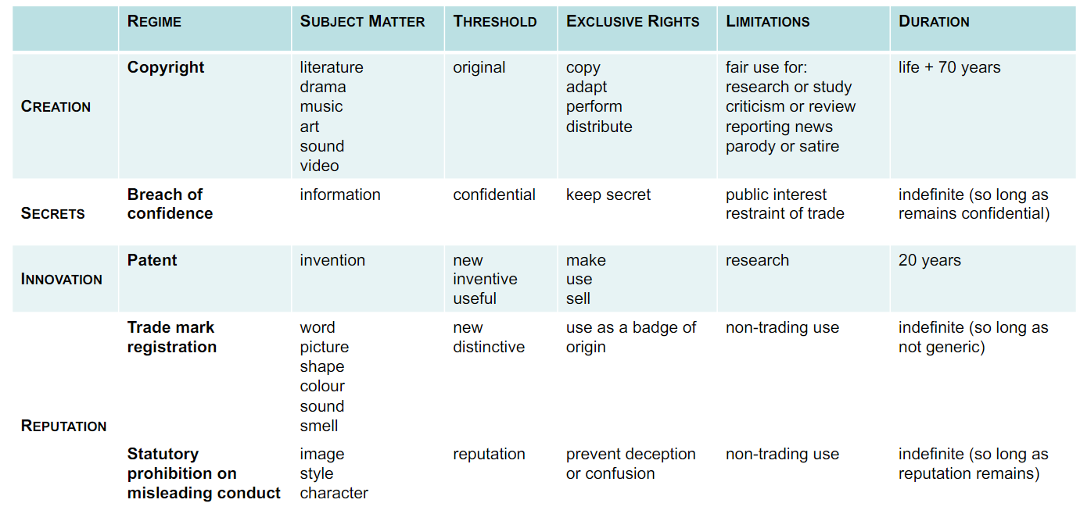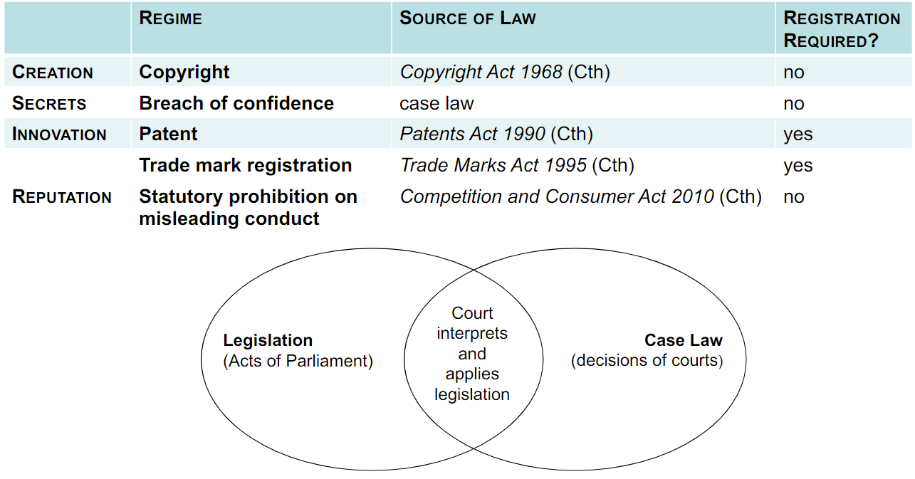

IPR laws are national

may be:

* assigned (= sold)
* licensed (= rented)
* bequeathed (= transferred under a Will)

IP, like normal property, can travel across borders. as such, international IPR treaties have been established.

* Minimum standards: Must follow international minimum standard
* National treatment: Must treat citizens of other countries no worse than their own citizens
* International recognition: An author that created a work in USA is treated as a person that created the work in Australia for the purpose of australian copyright act
* Right of priority: If a person applies in country A on date 1/1/2000 but applies in another country B on 1/1/2005, the original date is dated back to 1/1/2000

# Copyright requirements

Has to be a work that originates from an author

# Different types of work that can be copyrighted

• Literary work

• Dramatic work

• Musical work

• Artistic work (painting, sculpture, drawing, engraving, photograph, building (or a model

thereof), work of artistic craftsmanship)

## Literary work

Computer program, compilation of words or symbols.

T shirt design does not classify as a literary work as the words must have substantial meaning/ minimum number of words quota

Includes lyrics

## Dramatic work

Choreographed show, script for film but not the actual film.

Must have sufficient unity to be capable of performance.

Variety shows do not infringe on copyright under dramatic work as it does not classify as a dramatic act because there is no unity capable of performance.

## Musical work

Melody and harmony

Can silence be copyrighted? 4’33 song

## Artistic work

Painting sculpture, drawing, engraving (both the print and the stamp), photograph (not film), building design. Despite it being an artistic work or not.

A work of artistic craftsmanship - Needs to be artistic.

Definition of craftsmanship: needs to have special skill or knowledge

Engage with it visually.

## Sound recording

Sound embodied in a recording and not the sound itself. Can exist as cassette tape/ mp3 file

## Cinematographic film

Recording of visual images and corresponding sound. Computer games are included.

Spinning of reels/ small flipbook do not embody a moving picture

## Sound/ TV broadcast

Broadcast of the sound and image but not the sound and image itself. It is the signal and electromagnetic field.

## Published Edition (not a work?)

Published edition of a literary, dramatic, musical or artistic work.

The layout of the text and script is protected but not the actual text.

This law is to protect publishers from the technology of photocopiers.

# Requirements to classify as a work

Work has to be originated from an author

Definition of author: Person who brings the work into existence in it’s material form.

Definition of material form: words spoken in casual speech is not material but it is only when it is recorded. What about objects?

Examples:

Person A tells a story, Person B writes it out in their POV. Person B is the author.

Person C tells a story, Person D copies the speech word for word. Person C is the author.

Authorship is the person that expresses the outcome

AI does something (makes a drawing) - Drawing is not a work as it does not have an author.

Monkey takes a photograph. The picture has no author.

# Exclusive rights for copyright

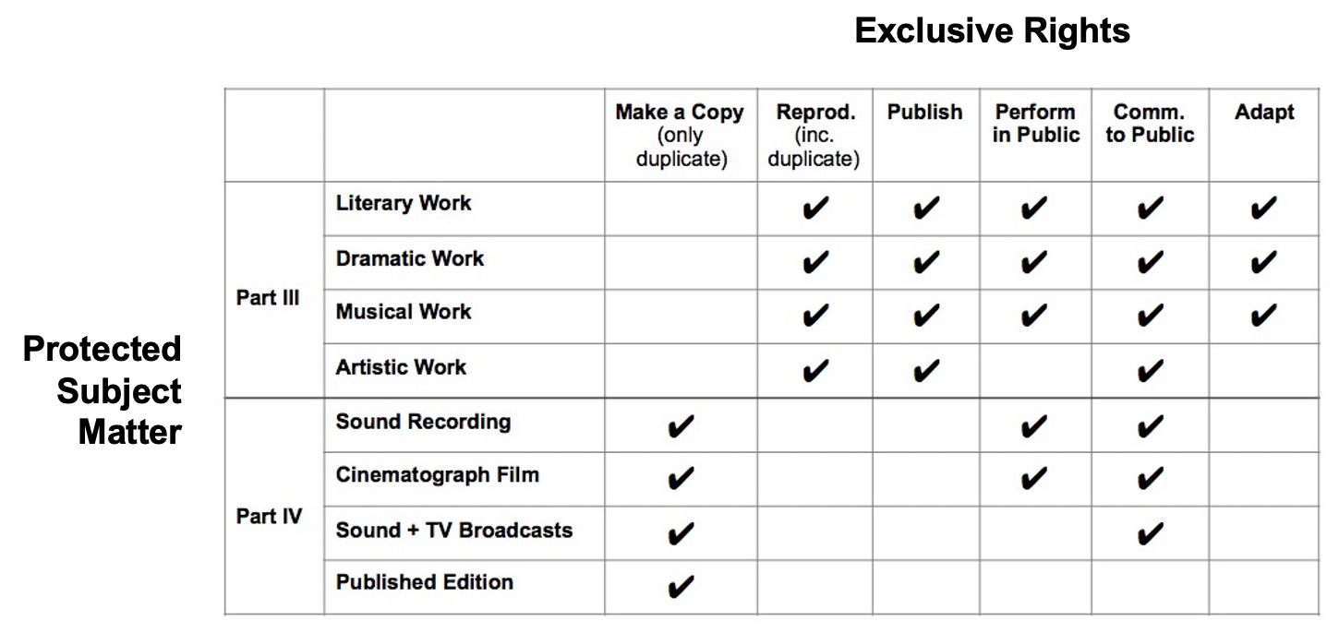

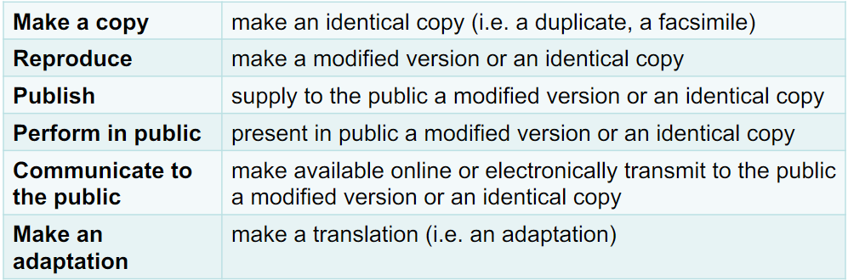

Publish: To distribute to the public

Reproduce:

* Analog -> digital
* 2D -> 3D
* Source code -> Object code
* Literary work -> Cinematic film
* Reproduction involves a sufficient degree of objective similarity between the two works
* Will be infringed upon if impugned work bears similarity to part of protected work regardless if it is substantial part of the impugned work

Substantialness

Quality and quantity is relevant

Quality has a higher “weightage” which refers to the originality of expressiveness

The part that has no originality is not a substantial part of the protected work

Objective similarity

Different defending stances plaintiff vs defendant:

* Mere coincidence
* Both taken from a common source
* P copied D
* D copied P

Infringement by D only if it is 4th scenario where D copy P

Case study:

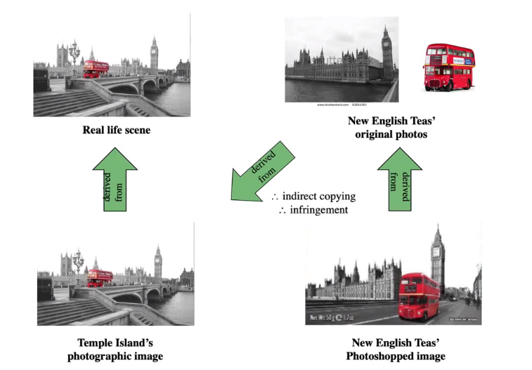

# Fair dealing purposes

* Research for study
* Criticism or review
* Parody or satire
* Reporting the news
* Giving professional legal advice
* Giving access to a person with disability

Other factors for fair dealing:

* Purpose and character of dealing
* Nature of subject matter
* Possibility of obtaining protected subject matter within a reasonable time at an ordinary commercial price
* Effect of dealing on potential market for protected subject matter
* Amount and substantiality of part dealt with

# Authorship

Definition of author is not defined except for in photography where it is the person who took the autograph.

Painter who paints a portrait for a person A who commissioned it. Person A has a physical copy but the painter is the author who owns the rights for it.

Author:

* Is not the person the who merely supplies the idea of the work
* Person who reduces the idea to the form of expression of the work

Journalist who turns a conversation into an article is the author of the literary work

A mere scribe who transcribes spoken words is not the author

Authorship in this sense only applies for copyright purposes.

If there are 500 people in a research team and only two people are the ones that write it down, copyright ownership goes to the people writing it.

## Multiple authors

If contributions can be separated from each other: Multiple works, each with a single author

eg: songs have composer and lyrics. composer is author of music and lyrics is a diff author

If contributions cannot be separated from each other: Joint authorship

Joint authorship needs two requirements:

1. contributions are original and significant: more than tinkering or improving another’s work
2. Agreement by all authors

## Makers

Some subject matters do not have authors but instead, makers.

In sound recordings, it would be the recording studio “person who owned the record embodying the sounds at the time the recording was made”

In cinematography films, it would be the production company. “person by whom the arrangements necessary for the making of the film were undertaken”

In broadcast, it would be radio/tv station “person who provided the broadcasting service by which the broadcast was delivered”

In the published edition, it would be the publisher.

# Exceptions to ownership of copyright

In general, the owner of copyrighted works is the author while other subject matter is the maker.

Exceptions:

Literary, dramatic or artistic work created by employees in course of employment is owned by the employer

Commissioned work owned by the commissioned person except in cases of photographs/painting/engravings/sound recording/cinematography film where it is owned by the commissioner.

Where there is an agreement (contract) regarding ownership – ownership is as per agreement

# Assignments and Licences of Copyright

Meaning of assignment – transfer of ownership of the exclusive rights of the copyright owner

Formalities of assignment – an assignment does not have effect unless:

• it is in writing; and

• it is signed by the assignor

Meaning of licence – consent / permission to do an act that would otherwise be an

infringement of copyright

• Formalities of licence

– not need be in a written, signed document

• unless: is an “exclusive licence”

Exclusive v. non-exclusive licence

– exclusive licence

• is exclusive of all persons, inc. copyright owner

• entitles licensee to sue for infringement

difference between an assignment: still have the rights for the work and therefore able to transfer ownership

Public license

A license by which a copyright holder grants permissions to any

and all persons in the general public

– creative commons

– open government licences

# Divisibility of copyright

Copyright owners may assign or licence their rights in a number of

ways:

– by rights: reproduction, publication, public performance or

communication, adaptation

– by format/medium: ‘physical rights’ v. ‘electronic rights’

– by place: in Australia

– by time/duration: only during the month of April

– by purpose: commercial/non-commercial, research, education

# Implied vs expressed license

– express licence

• licence expressly granted (in writing or orally) by copyright owner

– implied licence

• licence implied by law

– implied as of necessity

– to give “business efficacy”to a transaction

– are non exclusive by nature

– for example: Architect hired to develop building plans implies a licence to reproduce the plans by building the house

– for example: Person buys a book that has tutorial for a dress design. Person can replicate the dress but **not for commercial purposes**

# Duration of copyright

Duration = life of author + 70 years

If the author died in April 2000, license expires January 2070.

For joined authorship, it is 70 years after the last author dies.

## Where the author is unknown:

– work is not made public within 50 years of being made

• date made + 70 years

– work made public within 50 years of being made

• date first made public + 70 years

## Duration of other subject matter:

•Sound recording + cinematograph film:

– 70 years from first publication

– if not made public within 50 years of being made: date made + 70 years

• Sound broadcast + TV broadcast:

– 50 years from when broadcast made

• Published edition:

– 25 years from first publication of the edition

# Protection of secrets

The general rule of law is that the noblest of human productions -- knowledge, truths ascertained, conceptions, and ideas – became, after voluntary communication to others, free as the air to common use. Upon these incorporeal productions the attribute of property is continued after such communication only in certain classes of cases where public policy has seemed to demand it

These exceptions are confined to productions which, in some degree, involve creation, invention, or discovery. But by no means all such are endowed with this attribute of property. The creations which are recognized as property by the common law are literary, dramatic, musical, and other artistic creations, and these have also protection under the copyright statutes.The inventions and discoveries upon which this attribute of property is conferred only by statute are the few comprised within the patent law.

There are also many other cases in which courts interfere to prevent curtailment of plaintiff's enjoyment of incorporeal productions, and in which the right to relief is often called a property right, but is such only in a special sense. In those cases, the plaintiff has no absolute right to the protection of his production; he has merely the qualified right to be protected as against the defendant's acts, because of the special relation in which the latter stands or the wrongful method or means employed in acquiring the knowledge or the manner in which it is used.

Action to restrain a breach of confidence

– elements of the action

– limitations on availability of the remedy

## Requirement to restain a breach of confidence

1. Confidential information
2. Imparted or acquired under an obligation of confidence
3. to be used by recipient in an unauthorized manner

**Confidential**

– means not publicly known

– i.e. not known by people who are free to use it as they please

**Information**

– very wide meaning

– Recipes, activities, genes (for farming)

**Obligation of Confidence**

Would a reasonable person understand that they are not free to use the information as they please? - Medical record

**Unauthorized Use**

Is a use that is other than the purpose for which the information is acquired

• In any case, is a use that is “unconscionable” - goes against human conscience

• eg: nudes

## Limitation on Availability of a Remedy-Unreasonable Restraint of Trade

• Restraint of trade

• Disclosure in the public interest

**Restraint of Trade**

• Distinguish between:

– confidential information ‘owned’ by employer e.g. recipes, customer lists

– background knowledge and skill of employee acquired during employment

**Disclosure in the public interest**

Distinguish between:

–in the public interest eg:7/11 underpaying employees. Employees went to public with their confidential salary statement.

–of public interest eg: Magazine saying the queen is dying and her sister is trying to take the throne.

# Patent

Rational

Stop monopolies and create free competition but gives limited monopoly to new manufacturers

## Patent application process

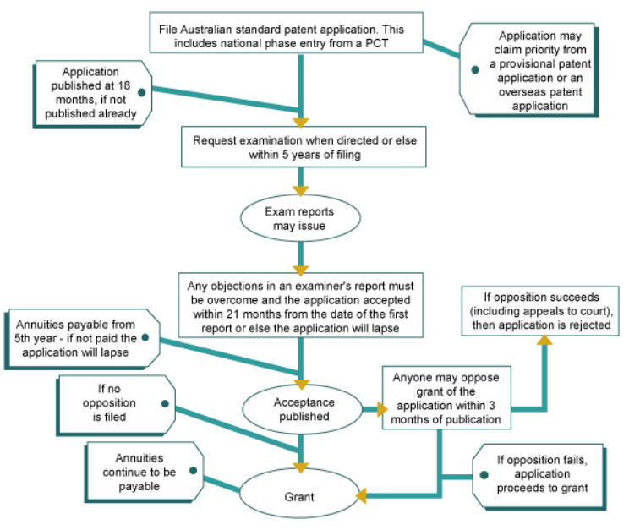

1. Application (by patent applicant)

– filing of a ‘patent specification’

• sets the ‘priority date’ - the point from which a patent application is examined for novelty and inventive step

• fee: approx. $370

1. Publication (by patent office)

– occurs 18 months after application (unless application withdrawn)

• NB: significance re protection of trade secrets

1. Examination (by patent office)

– search of ‘prior art’

– assessment of patentability

– possibility for amendment of application

– decision to accept or reject application

1. Acceptance (by patent office)

– acceptance of application if found to satisfy patentability requirements

– publication of notification of acceptance

1. Opposition (by third parties)

– occurs if an opposition is filed within 3 months of acceptance

1. Grant (by patent office)

– occurs if no opposition, or if an opposition is unsuccessful

– rights of patentee run from date of filing

– date of grant is first date on which patentee can sue for infringement

– rights last for up to 20 years from date of filing

1. Renewal (by patentee)

– renewal fees payable annually, from 5thanniversary of filing

application

• years 5-10: approx. $300

• years 11-15: approx. $550

• years 16-20: approx. $1,250

• years 21-25 (pharma patents only): approx. $2,550

1. Revocation (by Court)

– occurs if court satisfied that patent should not have been granted

• e.g. because it not satisfy one or more of the requirements of:

– patentable subject matter

– novelty

– inventive step

– utility

# Patentable subject matter

1. Only inventions are patentable
2. Unpatentable subject matter
3. Excluded subject matter

encouraging innovation by means which do not stifle it

Relevant considerations

– whether patentability would:

• give rise to a “large new field of monopoly protection with potentially negative effects”?

• have a “chilling effect on activities beyond those formally the subject of” exclusive rights of patentee?

• involve the court in “assessing important and conflicting public and private interests and purposes”?

**Invention**

US Supreme Court:

– “Anything under the sun that is made by man” (Diamond v.

Chakrabarty 1980)

• Australian High Court:

– “An artificially created state of affairs in the field of economic endeavour” (NRDC v Commissioner of Patents 1959) - basically anything created by man but in the appropriate field

case study:

Cancer Voices Australia v Myriad [2013] FCA 65

D’Arcy v Myriad Genetics [2014] FCAFC 115

Patented an isolated nucleic acid coding for a mutant gene that causes breast cancer and was granted. Because the acid was isolated from the naturally occurring gene.

Medical field patent was an appropriate field.

High court argued that the NRDC test was too simplistic in nature. Eventually was revoked as it was not an invention and was not a patentable subject matter.

**Unpatentable subject matter**

Human beings, and the biological processes for their generation, are not patentable inventions

Case study: Fertilitescentrum’s Application (APO 04)

A method of growing preblastocyst human embryos, the method including the step of incubating the embryos in vitro in a culture medium containing…

A human life form is created at fertilisation

• i.e. when the sperm enters the ovum

– but full status of human being not acquired until birth

• i.e. a human being is in the process of generation from fertilisation until birth

Prohibition on patenting:

– a “human being” applies to a fertilised ovum and any manifestations of it

– a “biological process for generation of a human being” applies to all biological processes from fertilisation to birth

**Excluded subject matter**

Some territories have excluded certain things to being patentable because these things may be commercially exploitable. Australia has not excluded anything so far.

Advisory Council on Intellectual Property (ACIP) recommendation for an ethical exclusion (in Feb. 2011):

– “an invention the commercial exploitation of which would be wholly offensive to the ordinary reasonable and fully informed member of the Australian public”

Members may exclude from patentability inventions, the prevention within their territory of the commercial exploitation of which is necessary to protect ordre public or morality, including to protect human, animal or plant life or health or to avoid serious prejudice to the environment, provide that such exclusion is not made merely because the exploitation is prohibited by law.

# Patent specification

Components of patent specification

1. Bibliographic information

* – informs when and by whom the invention made
* • for purpose of knowing priority date and patentee

1. Description (inc. drawings)

* – describes the invention
* • for purpose of knowing how it works
* – and thus how to make it

1. Claims

* – define the invention
* • for the purpose of knowing what it is
* – and thus what is protected
* Usually have multiple claims. Can have independant or dependant claims
* Narrow definition so new patent does not infringe on previous ones
* Claim has to satisfy definition of utility

## Requirement for utility

An invention must be useful–in the sense that it has a use which is:

* Useful is different from our definition. Butt kicking machine is acceptable because there is use for it even though it may be “useless” in our defintion

• specific, and

• substantial, and

• credible

Example: if claim invented something but does not state what it is used for, it is not a utility

## Requirement of novelty

**Novelty (newness):**

– an invention is novel if it does not exist in the “prior art”

– an invention is not novel if any single piece of prior art discloses all

the features of the invention (as claimed)

Prior art does not have to be a previous patent.

• Prior art can be an expired patent

• Prior art is all information that was “publicly available”at the “priority date”

• Publicly available information:

– information disclosed in a document that is published

• “published” = not secret

– i.e. not subject to an obligation of confidence

– information disclosed in an act that is done in public

• “done in public” = not done in secret

– i.e. not done before people under an obligation of confidence

• Priority date:

– date of filing patent application

**Inventive step (non-obviousness):**

– an invention involves an inventive step if it would not have been “obvious”to a “person skilled in the art”(PSA), taking into account:

• the “prior art”, and

• the PSA’s “common general knowledge”at the priority date

PSA = hypothetical person to whom patent is addressed

– a skilled, but **uninventive**, worker in the field of the invention CGK = mental “tools of the trade” of the PSA

• common – information known to all of those skilled in the art

• general – forms the background knowledge of those skilled in the art, being:

– information in the memory of the PSA

– information the PSA would consult as a matter of course

• knowledge – information that is known

• “Obvious” from the Latin obviam=“in the way”

– “that which lies in the path”

• “Problem-solution” approach to assessing non-obviousness:

**1**. identify the closest piece of prior art

**2**. determine the difference(s) between the invention and that prior art

**3**. determine the effect brought about by the difference(s)

=> problem(to which the invention is a solution): how to adapt or modify that prior art to achieve this effect?

**4**. determine whether the claimed solution is obvious to the PSA

– given the prior art and their CGK, what step(s) would the (non-inventive) PSA take to solve the problem?

– would step(s) lead to the claimed solution?

# Patent infringement

Exclusive right for patents - To exploit the invention

If invention is a product:

Rights include:

* Making, hiring, selling, importing, using as defined in the claim

If invention is a process:

Rights include:

* using the method / process as defined in the claim
* make, hire, sell, import or use of the method or process as defined in the claim

If your patent is australian and someone does the same thing in new zealand, it is ok because you do not have an new zealand patent. but if they were to import the product to australia, then it is infringement.

When determining infringement, a patent claim is to be given a purposive construction

• A purposive construction is determined by answering the question: what would the PSA understand the patentee to have intended by use of the word/phrase in issue?

– if the answer is:

• a strict interpretation – any variant is outside the claim

• not a strict interpretation – a variant is within the claim

– unless the variant materially affects the way the invention works

In the case study, it was determined that it was not a strict interpretation that the beam had to be vertically perpendicular. So the 6 degree change is an infringement

## Multi-Step Approach to Construction

1. Identify the integers of claimed invention

2. Determine if all the integers of claimed invention, literally construed, are present in the alleged infringing embodiment

– if yes: infringement

– if not:

3. Determine if the variance (the missing or the changed integer) is essential to the invention

• using a “Catnic purposive construction”, by applying the Improver questions

– if no: infringement

– if yes: no infringement

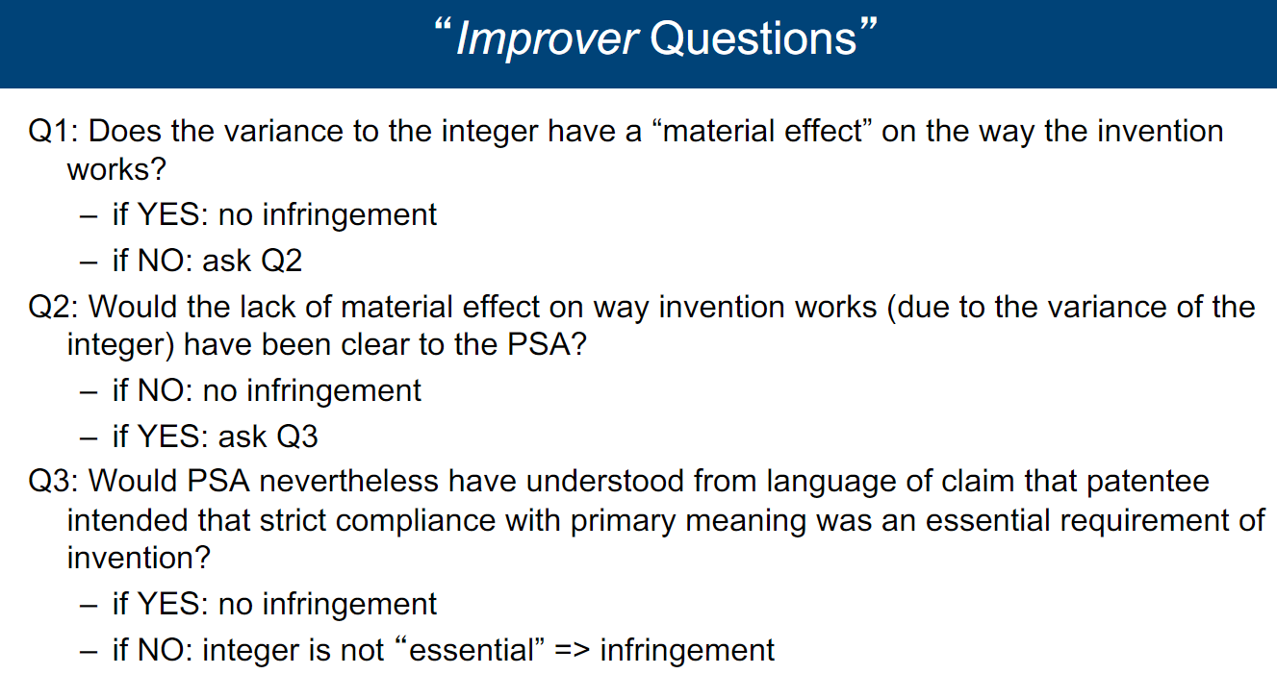

## Defenses to Infringement

• **Prior use**

– no infringement if Defendant was making the patented product or using the patented process immediately before the filing date (i.e. priority date)

• **Experimental use**

– no infringement where an act done “for experimental purposes relating to the subject matter of the invention”

• **Invalid claim**

– No infringement if the claim was not validly granted

* Patent is granted at first but later reconsidered that it is not valid

• e.g. because it lacks novelty or an inventive step

# Trademark

Definition: a **sign** used to distinguish the goods or services of one trader from the

goods or services of another trader

**“Sign”**includes:

– word

– device

– shape

– colour

– sound

– scent

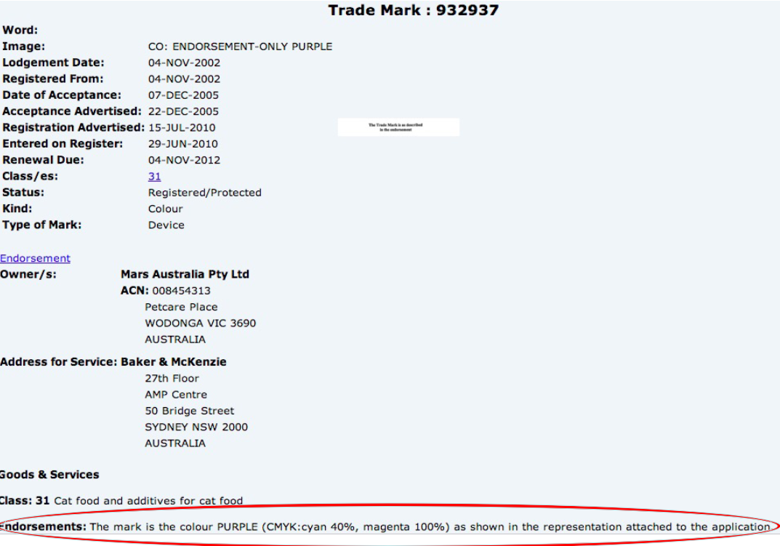

MGM: Lion roaring - sound

**Distinguish:**

– **inherent**

• inherent characteristic of mark enables it to distinguish

eg:

– the name of a person represented in a special or particular manner: ChristianDior without space

– the signature of the applicant for registration

– an invented word

– a word not having direct reference to the character or quality of the goods or services in respect of which registration is sought and not being, according to its ordinary meaning, a geographical name or a surname: Apple for computers or Tasty for car. And not Tasty for chocolate

– **factual**

• actual use of the mark enables it to distinguish

Case study of banana toothbrush: Banana shape is not trademarkable because if someone were to do a banana toothbrush, they would likely have to have the same/ similar shape.

Trademark works in respect to the class of goods.

Color of toothbrush is trademarked.

**Goods or Services**

• Goods

– tangibles – e.g. “confectionery”

• Services

– intangibles – e.g. “retailing”

**Trader**

Trader is one who engages in trade or commerce

≠ private or domestic activities

• Personal names as such are not trade marks

– unless person is using their name as a trade mark - e.g.:

• ALANNAH HILL - designer (fashion products) accepted

• GRANT BURGE - wine maker (wine) accepted

## Prohibitions on trademarks

Use of mark is contrary to law

Mark is “scandalous”

* Jesus and Kunt (Pronounceable) is scandalous
* cnut , farkew is not scandalous

## Obtaining trade mark registration

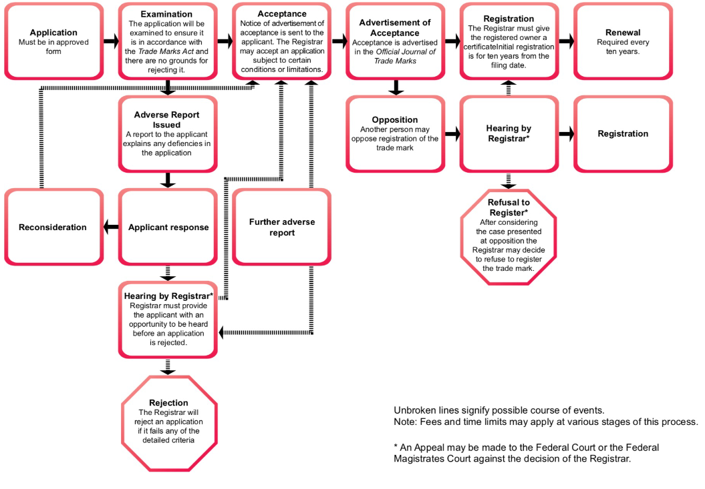

**Application** (by trade mark owner)

– filing of a trade mark application

• representation of mark

• description of goods and/or services in respect of which registration is sought

• fee = approx. $250 per class

**Publication** (by trade marks office)

– 1-2 days after application

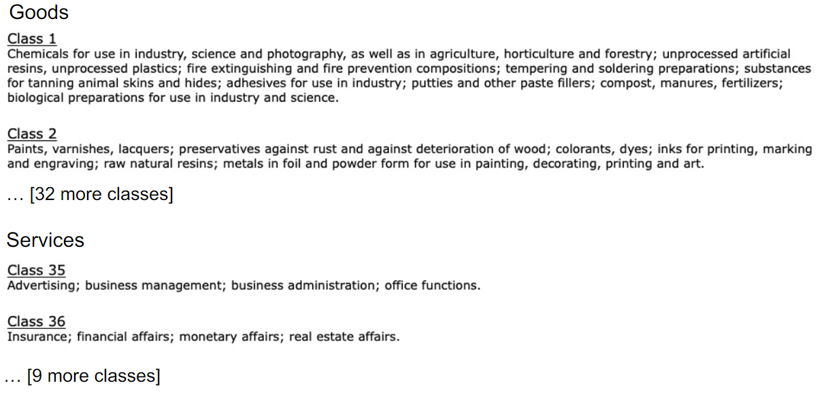

**Examination** (by trade marks office)

– search of register for prior trade mark registrations

– assessment of registrability

– possibility for amendment of application

– decision to accept or reject application

• usually given within 3-4 months of filing application

**Opposition** (by third parties)

– possibility of opposition to grant by third parties

**Grant** (by trade marks office)

– rights of registrant run from date of filing

– date of grant is first date on which registrant can sue for infringement

– rights last for 10 years from date of filing, and capable of being

renewed

**Renewal** (by trade mark registrant)

– need pay 10-year renewal fees, beginning on 10thanniversary of filing

application

– renewal fee = approx. $400 per class

Loss of Registration – ‘Genericide’ - when a brand becomes generalized. eg: aspirin

## Infringement of trademark

There will be infringement of a registered trade mark only where **all three** of the following elements are present:

1. There is a sign that, in respect of the registered trade mark, is either:

* substantially identical, or
* deceptively similar;

1. The sign is used in relation to goods/services that, in comparison to the goods/services in respect of which the registered trade mark is registered, are either:

* the same (– but only if actual use is likely to deceive or cause confusion), or
* of the same description or closely related – but only if actual use is likely to deceive or cause confusion, or
* unrelated – but only if:
  + the registered trade mark is well known, and
  + the sign indicates a connection between the goods/services and the registered trademark owner, and
  + for that reason the registered trademark owner’s rights are adversely affected;

1. The sign is used as a trade mark.

### Determining substantial similarity

– a side-by-side comparison

– noting similarities and differences

– assessing the importance of similarities and differences having regard to the essential features of the registered trademark

– identifying the total impression of resemblance or dissimilarity that emerges: Shell Company of Australia Ltd v Esso Standard Oil (Australia) Ltd (1963) 109 CLR 407



Too similar. insightradiology had to move to xplore radiology

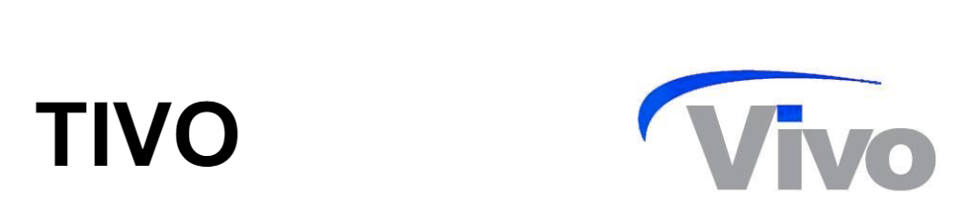

Not similar. We compare the words Tivo to Vivo and not the letters individually.

We also look at the fact that the design in Vivo is very unique.

### Determining deceptive similarity

A trade mark is taken to be deceptively similar to another trade mark if it so nearly resembles that other trade mark that is likely to deceive or cause confusion

Determined by:

– not a side-by-side comparison

– the effect or impression produced in minds of consumers

– as a result of similarity of the marks in all the circumstances

• Based on an imperfect recollection of the registered trademark, is there a real, tangible danger that the ordinary person, upon seeing D’s sign, will be caused to wonder whether it might not be the case that P’s and D’s goods/services come from the same source?

• A mere possibility of confusion is not enough

Case study:

Neola vs Pianeola (not deceptive similar: having regard to the nature of the customer, the article in question, and the price at which it is likely to be sold, and all the surrounding circumstances no man of ordinary intelligence is likely to be deceived)

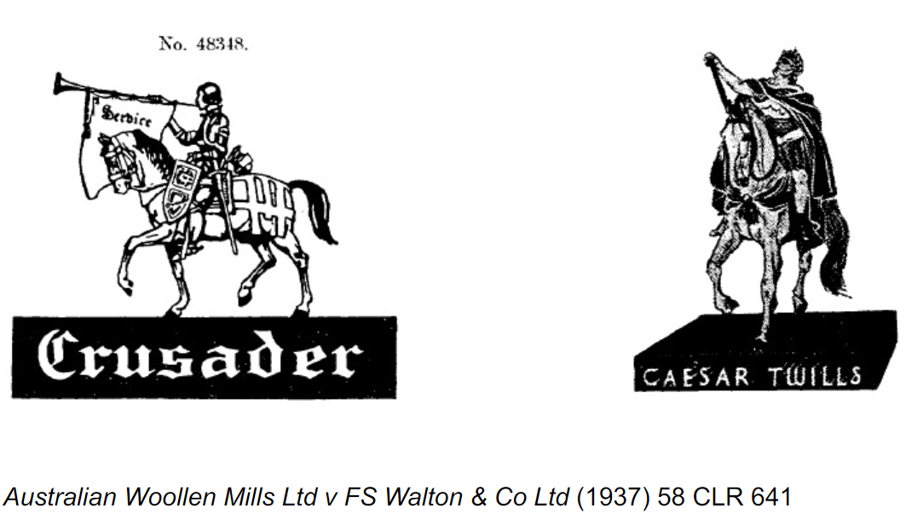

Not deceptively similar: we find it very hard to suppose that anyone would confuse Caesar as a name or the representation of Caesar with the title Crusader or with the brand of the appellant. The impression created by each of the respective pictures or representations strikes our minds as widely dissimilar. [Their Honours noted the banner and trumpet would be the most definite elements of the impression left by the registered trade mark. These elements are absent from D’s mark.]’

Rainmaster vs Rain King:

Not deceptively similar - the only similarity between the two marks is the common prefix “Rain” and...this similarity is not sufficient to create a reasonable likelihood of deception when the remaining portions of the marks are so different.

Berlei (pronounced bar-ley) vs Bali-bra

It is deceptively similar - If it be supposed that [the Bali Company Inc] were to apply its mark to brassieres of the kind manufactured by [Berlei Hestia Industries Ltd] it would be difficult, in my view, to resist the conclusion that there would be a real danger of confusion

Tivo vs Vivo

Background: Tivo had revolutionary tv but did not import to australia. Vivo used the technology to their TV in australia. Court ruled deceptive similarity.

The question is whether ordinary people may be led to wonder as to whether goods bearing the TiVo and Vivo trade marks have the same source...ordinary people interested in buying goods of the kind in question might well make such a connection before the point of sale...The differences in visual appearance of the trade marks and prices of the goods might be discounted subliminally as a mere indication that the two brands belong to one family of which the TiVo

product represents the luxury end of the range and the Vivo product the economy end of the range

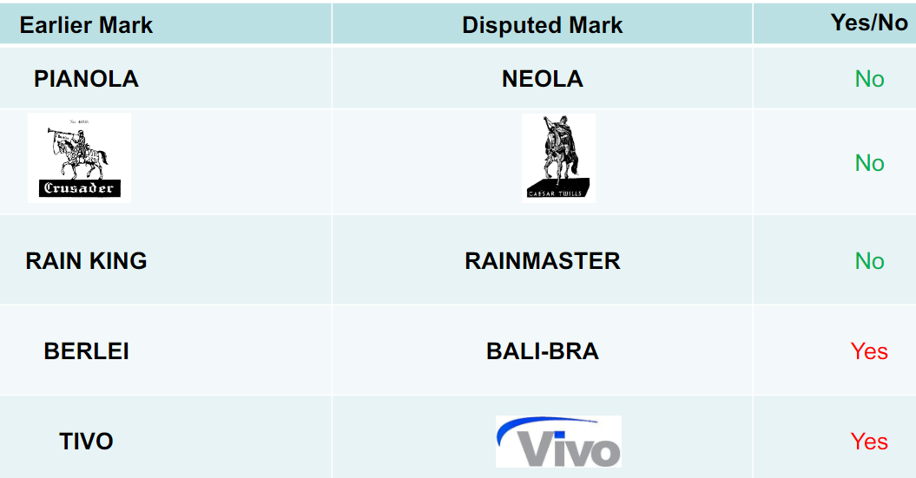

### Goods or service of the same description/ closely related

• The expression “goods of the same description” is a term of art, implying a relationship between goods such that they would be seen by purchasers as having the same trade origin if sold under deceptively similar marks

• Factors to consider:

– Nature, including characteristics and origin

– Uses, including purposes

– Trade channels, including wholesalers and distributors

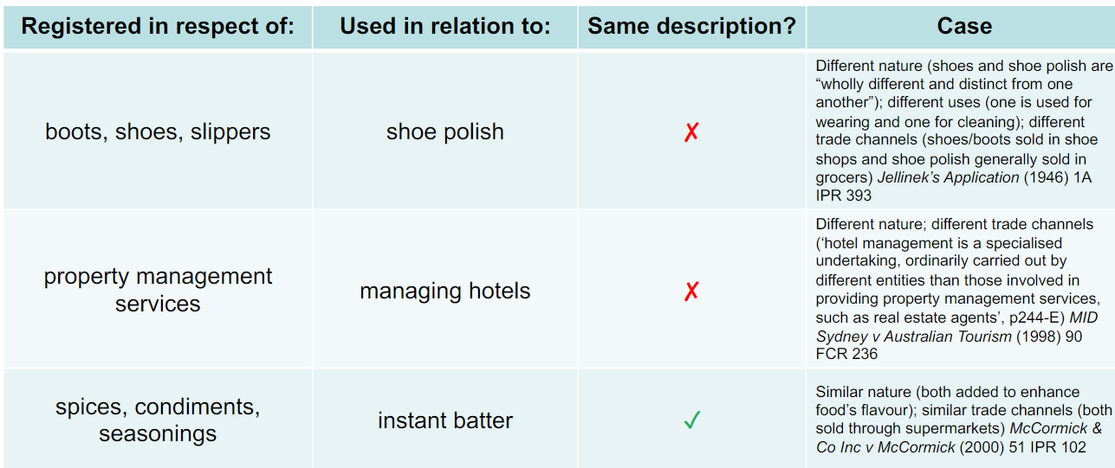

• The relationships are generally defined by the function of the service with respect to the goods

• Services which provide for the installation, operation, maintenance or repair of goods are likely to be treated as closely related to those goods

– TV repair services are closely related to TVs

• What is the function of the serviceand what is the good? Australian Law of Trade Marks and Passing Off Online, [35.1505]

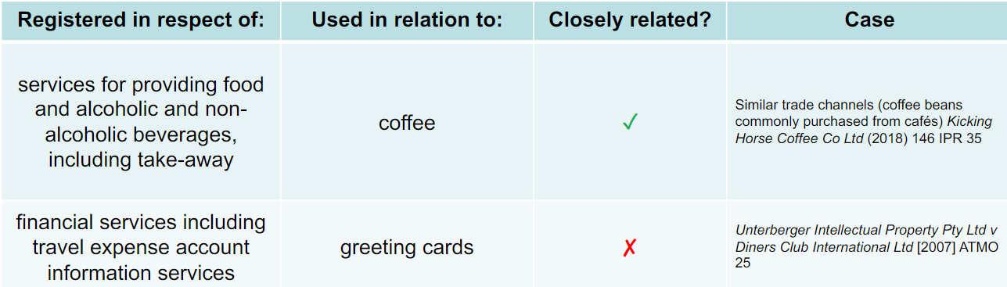

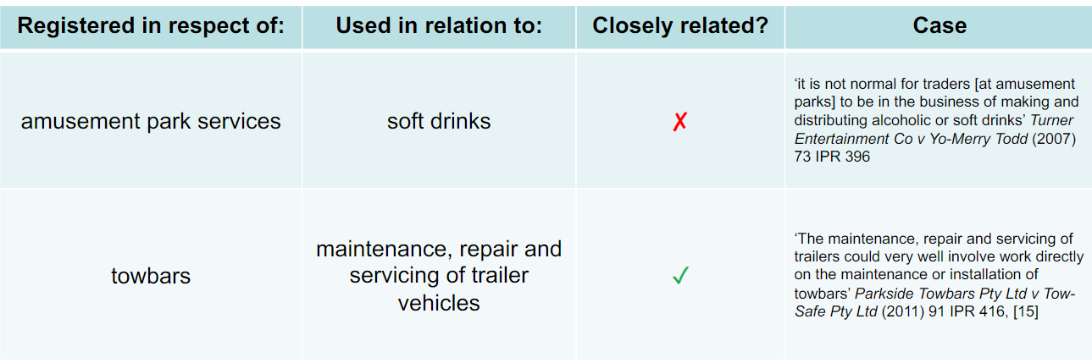

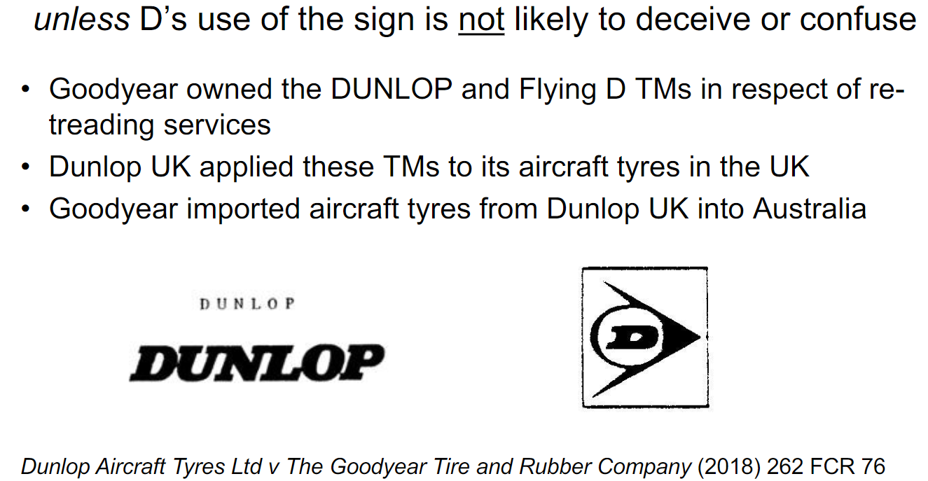

unless D’s use of the sign is not likely to deceive or confuse

• Dunlop UK sought a licence from Goodyear to use the DUNLOP and Flying D TMs on aircraft tyres in Australia. Goodyear declined

• Dunlop UK then began using the DUNLOP and Flying D TMs on aircraft tyres it sold in Australia without Goodyear’s permission

• Goodyear sued Dunlop UK for TM infringement

• Dunlop UK relied on the defence that its use of the TMs is not likely to deceive or cause confusion

The court held:

– aircraft tyres are closely related to re-treading services; but

– because of the “highly specialised” market for aircraft tyres, purchasers would not be deceived or confused. They would know that aircraft tyres sold in Australia by reference to the DUNLOP and Flying D TMs were made by Dunlop UK (and not by Goodyear)

### Well known marks

Factors include:

• the degree of knowledge or recognition of the mark

• the extent of use of the mark

• the extent of promotion of the mark

Would the sign used by D be likely to be taken as indicating a connection between the unrelated goods or services and the registered owner of the trade mark?

• P suffers negative publicity due to inferior quality of D’s goods/services

• P’s mark is “diluted” (loses its value)

• P’s opportunity to expand into the market for D’s goods/services is impaired

Look at week 10 part 5 for case studies.

### Use as a trade mark

Case study: Michelin v General Workers Union of Canada [1997] 2 FC 306

The Union distributed leaflets and information sheets, and displayed posters showing the Michelin Man

Conclusion:

Although the union organising activities might have reaped financial rewards, the trade-marks were not “used” in association with goods or services in the ordinary course of trade

• Handing out leaflets and pamphlets to recruit members into a trade union does not qualify as commercial activity

# Protection against Misleading or Deceptive Conduct

**Tort Law Prohibition**

A remedy under tort law for “passing off” is available where plaintiff (P) can show:

1. Reputation – held by P in something

– e.g. consumer association of P with a distinctive sign

•e.g.an unregistered trade mark

2. Misrepresentation – through an action by defendant (D)

• e.g. a representation that the goods/services of D are in fact the

goods/services of P

– e.g. through D’s use of a sign similar to P’s sign

3. Damage – caused to P by D’s action

• e.g. loss of sales

– e.g. D’s goods/services purchased by customers who would’ve purchased

P’s goods/service if D had not used P’s sign

**Australian Consumer Law, s.18(1):**

A person must not, in trade or commerce, engage in conduct that is misleading or deceptive or is likely to mislead or deceive.

Conduct

– e.g. a representation of a connection between P and the goods/services of D

• e.g. through use, by D, in relation to competing goods / services, of a sign that is similar to a sign in which the P has developed a reputation

That misleads or deceives

– e.g. that leads to a false belief

• e.g. a belief there is a connection between D and P (when there isn’t)

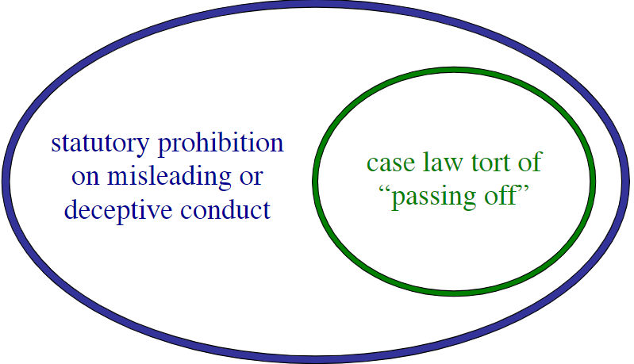

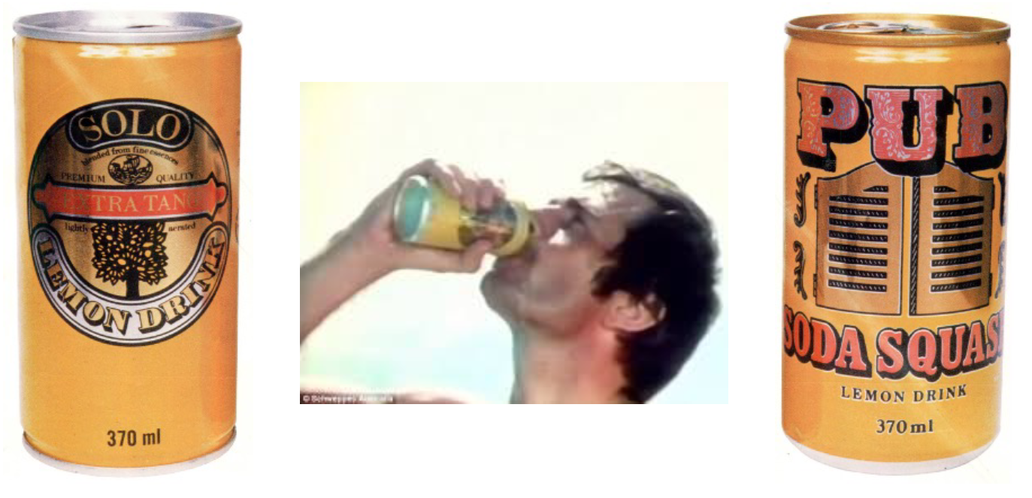

Court deemed that pub soda squash has sufficiently distinguished itself.

Case study: Chantelle vs Cheri

Court deemed that the items were similar only because of combined attributes being similar.

Case study: Pacific Dunlop vs Hogan

Character trademark

Viewers of the ad. could not reasonably conclude that Hogan had consented to or authorized the ad.

Evidence of confusion is weak

No misrepresentation was made by D => no MoDC by D

– [p427: 43] distinguish between:

• “mere” caricature

– innocent because gives impression that person caricatured would not have agreed with portrayal

• “embedded” caricature

– not innocent, because gives impression that person caricatured is endorsing product

– [p428: 3] in this case: not mere caricature

character merchandising does not set off a logical train of thought

• “an association of some desirable character with the product proceeds more subtly to foster favourable inclination towards it”

– [33] consumer is moved to wear something “belonging in some sense”to Crocodile Dundee (the persona of P)

* The last judge thought that the plantif was making a false association of the product with the character which is breach of law. The ad was not considered parody because the plaintiff’s performance was already a parody

# Exam

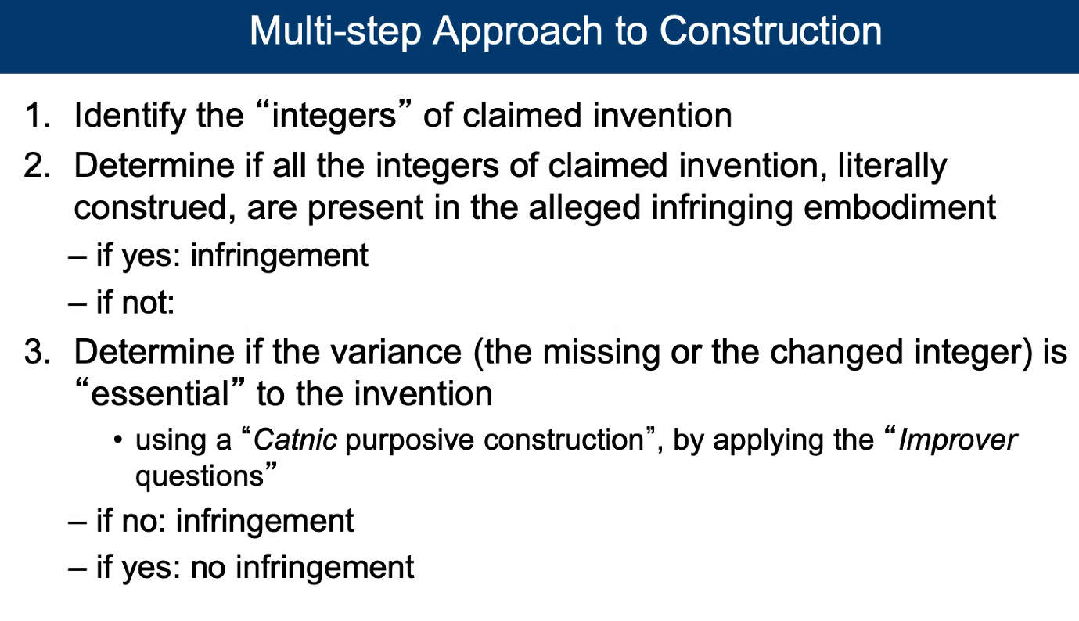

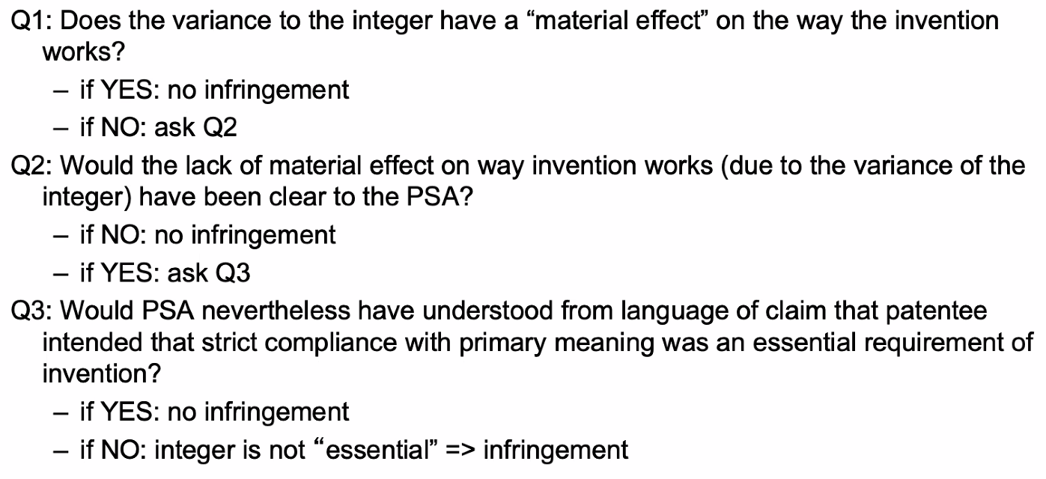

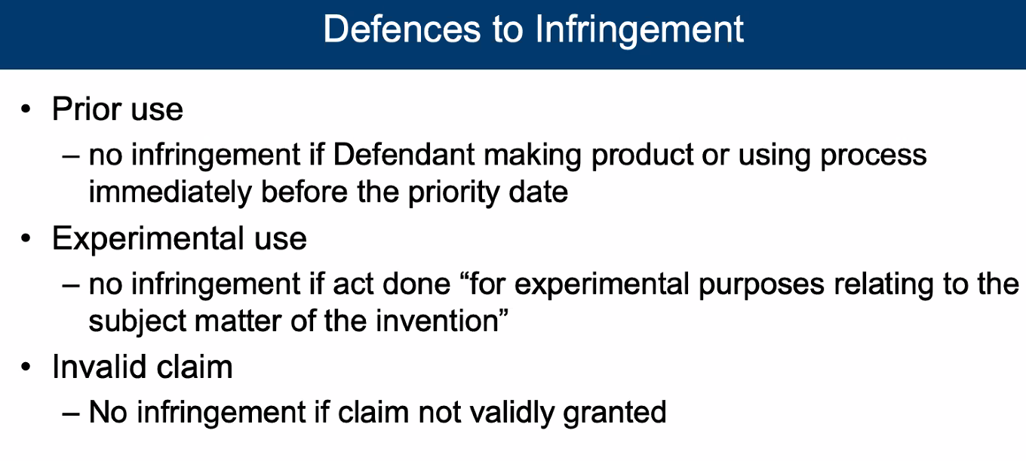

Probably not going to need:

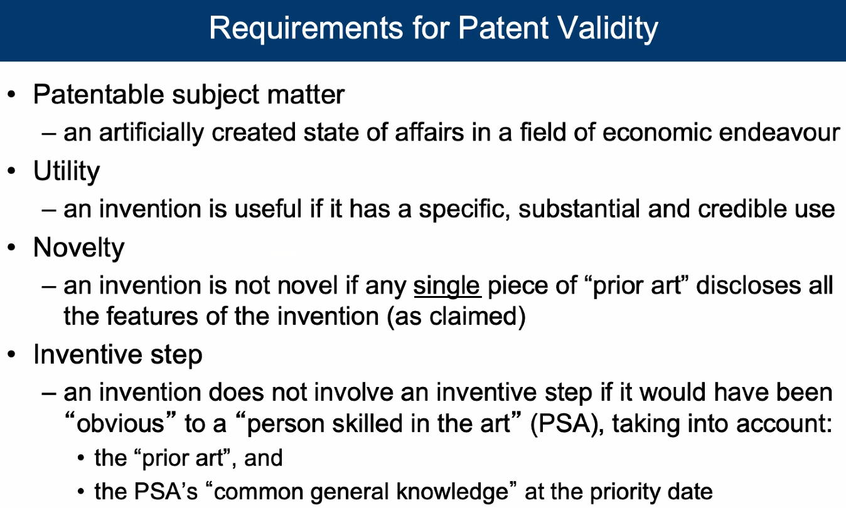

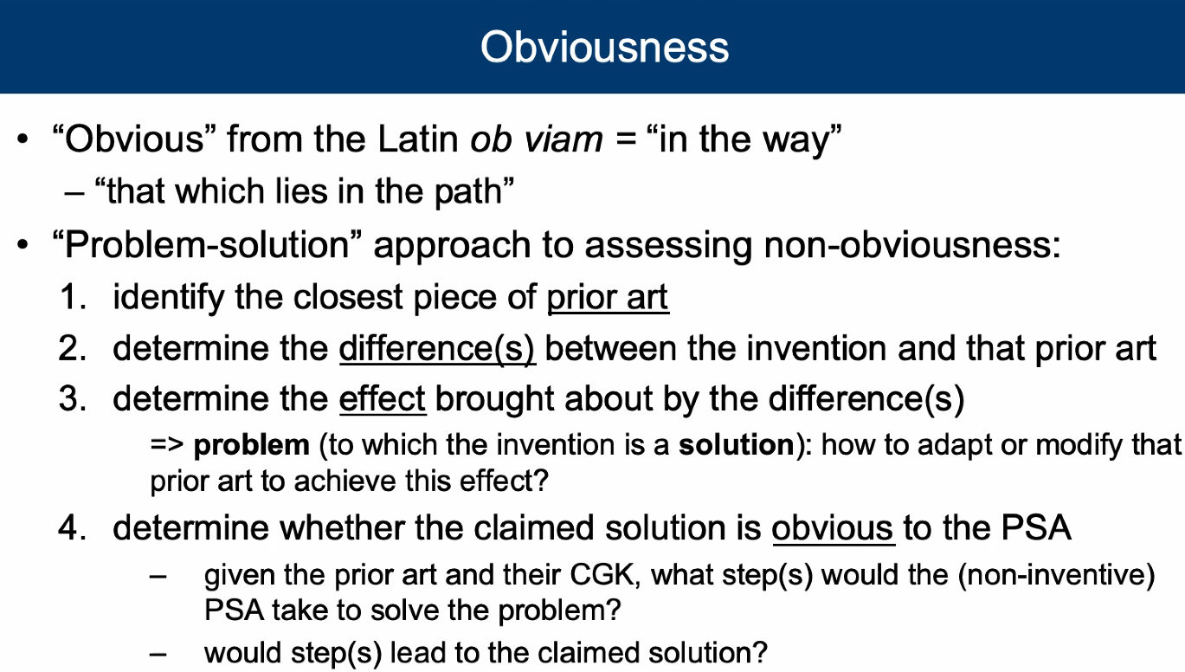

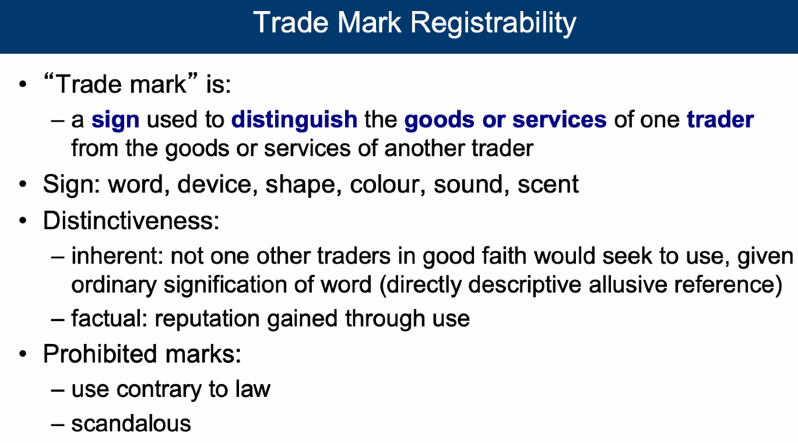

1/10 of max word count - 4000 words - wiggle room

do not bother saying facts already given.

in coco chanel example, the france and paris do not matter as the trademark in question is just COCO CHANEL

